PROVISIONAL PATENT APPLICATION
UNITED STATES PATENT AND TRADEMARK OFFICE
Title: SYSTEM AND METHOD FOR FAIL-CLOSED CONSTITUTIONAL ENFORCEMENT AT EDGE EXECUTION BOUNDARIES WITH HARDWARE-ANCHORED ATTRIBUTION
Inventors: Jacob Dean Lawlis
David Keith Lawlis
Assignee: AnchorTrust Holdings LLC
Date: November 21, 2025

CROSS-REFERENCE TO RELATED APPLICATIONS
This Provisional Patent Application extends the governance architecture disclosed in the Provisional Patent Application No. 63/898,056 Titled” SYSTEM AND METHOD FOR ATTRIBUTION-GOVERNED MULTI-TIER ORCHESTRATION” filed October 12, 2025.

ABSTRACT
A system and method for constitutional policy enforcement at edge execution boundaries addresses the problem that distributed edge computing lacks cryptographically enforceable governance, attribution preservation, and offline operational capability. The solution employs hardware-anchored capability tokens with sender-constraining bindings, compiled policy engines executing intermediate representations, authenticated service discovery with cryptographic validation, durable audit commits with crash-consistency guarantees, and trust-weighted peer mesh delegation with attribution-preserving receipt lineage. Edge nodes enforce a no-token-no-run invariant through in-band policy evaluation backed by hardware attestation, preventing execution when capability tokens, attestation evidence, policy evaluation, or attribution binding fails. Economic routing operates constitutionally through attribution-anchored receipts that automatically compute and emit machine-verifiable settlement instructions for distribution to attributed contributors without platform intermediation. This creates a constitutional substrate for edge-native artificial intelligence orchestration with cryptographic enforcement of attribution, governance, and economic participation—enabling sovereign-compliant, offline-capable, and economically self-enforcing distributed intelligence execution.

FIELD OF THE INVENTION
The present invention relates to systems and methods for enforcing constitutional governance at edge execution boundaries in distributed artificial intelligence and orchestration environments. The invention enables cryptographically enforced policy compliance, hardware-anchored attribution preservation, offline operational capability, authenticated service discovery, and automatic economic routing in edge computing deployments where conventional cloud-centric governance mechanisms are unavailable or insufficient.
The invention addresses the critical gap in edge computing where execution occurs on distributed, intermittently connected devices that lack continuous oversight from central control planes. Current edge platforms cannot enforce attribution requirements, maintain constitutional compliance, or preserve economic participation guarantees when operating offline or with degraded connectivity. This invention provides technical mechanisms for constitutional enforcement that operate locally at edge nodes through hardware-backed attestation, cryptographic capability tokens, compiled policy evaluation, and tamper-evident audit structures—enabling trustworthy, attributable, and economically enforceable execution at the edge.

BACKGROUND OF THE INVENTION
Modern distributed computing increasingly relies on edge execution to reduce latency, improve resilience, enable offline operation, and comply with data sovereignty requirements. However, edge deployments face fundamental governance challenges: execution occurs on devices outside direct control, connectivity may be intermittent or absent, and central enforcement mechanisms cannot gate every operation.
Conventional edge platforms focus on workload distribution and resource management but lack mechanisms for:
- Hardware-anchored attribution enforcement at the edge, ensuring creator identities are cryptographically bound to execution even when devices operate offline
- Fail-closed constitutional enforcement through no-token-no-run invariants that deny execution when attestation, capability, policy, or attribution requirements are not satisfied
- Sender-constrained capability tokens that prevent unauthorized token replay and ensure capabilities are exercised only by authorized principals
- Compiled policy evaluation enabling deterministic, performant, and side-channel-resistant governance decisions at resource-constrained edge devices
- Authenticated service discovery protecting against phishing, man-in-the-middle attacks, and malicious endpoint substitution in edge environments
- Durable audit commits with crash-consistency guarantees ensuring no acknowledged operation can be lost during power failures or system crashes
- Trust-weighted peer mesh delegation enabling workload offloading while preserving attribution lineage and economic participation across delegation hops
- Offline-capable reconciliation allowing edge nodes to accumulate signed receipts during disconnected operation and deterministically reconcile upon reconnection
- Attribution-governed economic routing that automatically computes and distributes royalty allocations based on cryptographic provenance chains without platform intermediation
Critically, no existing architecture provides constitutional enforcement at the edge—where governance requirements are enforced through cryptographic mechanisms operating locally on edge devices rather than through external oversight that cannot reach offline or intermittently connected nodes.

DEFINITIONS
For clarity and to avoid indefiniteness, the following terms are defined as used in this specification:
Constitutional enforcement means in-band, fail-closed technical gating enforced at the runtime boundary prior to executing protected operations, wherein governance requirements are cryptographically enforced through hardware-backed mechanisms rather than external policy overlays that may be bypassed.
Attribution object means a cryptographically signed descriptor binding a contribution (model, dataset, prompt, orchestration logic, or other configuration item) to a principal identity, with parent references for provenance tracking and economic allocation metadata.
External integrity service means any append-only timestamp or notarization facility providing verifiable immutability guarantees, including but not limited to: public transparency logs, timestamping authorities, distributed ledgers, multi-party computation notaries, and private notarization services.
Trusted time source means a network or hardware source with verifiable freshness and authenticity, including but not limited to: Roughtime protocol servers, secure real-time clocks, attested Network Time Protocol (NTP) servers, GPS time receivers, and hardware-backed timestamping from trusted platform modules.
No-token-no-run invariant means a fail-closed enforcement property whereby execution is denied when any of capability token validation, hardware attestation verification, policy evaluation, or attribution binding fails, preventing unauthorized execution through technical mechanisms rather than procedural recommendations.
Monotonic sequence means a strictly increasing numerical sequence that prevents replay attacks and double-spend by rejecting any sequence number that is not greater than the previously committed number, enforced through hardware monotonic counters or cryptographic commitment schemes.
Intermediate representation (IR) means a platform-neutral compiled instruction format (e.g., WebAssembly, eBPF, bytecode virtual machine) executed with deterministic semantics and bounded resource consumption, enabling safe policy evaluation across heterogeneous edge devices.
Proof-of-execution attestation means a hardware-anchored cryptographic quote binding a measurement of the executed intermediate representation and request context to a device identity, proving the computation occurred in a trustworthy environment.
Settlement instruction means a signed, machine-verifiable directive specifying recipients, amounts or weights, and provenance proof references for automated distribution by a payment or accounting system without human intermediation.
Edge-local capability (EL-CAP) means a time-bounded, device-anchored capability token minted by an edge node from a control-plane capability anchor, wherein the edge-local capability includes: (a) cryptographic binding to the originating capability anchor through hash reference or signature chain, (b) local spending ceilings and operational limits that are strictly bounded by the control-plane allocation, (c) temporal validity constraints enforced through expiration timestamps, (d) device-binding through confirmation claim (cnf) binding the capability to hardware-backed device keys, and (e) monotonic sequence numbers preventing double-spend and replay attacks. Edge-local capabilities enable offline-capable constitutional enforcement by allowing edge nodes to mint bounded sub-capabilities for local operations while maintaining cryptographic proof of authorization that can be deterministically reconciled with control-plane records upon reconnection through Merkle-proven spend logs and receipt chains.

DETAILED DESCRIPTION

1. Sender-Constrained Capability Tokens
Systems disclosed herein employ sender-constrained capability tokens that are cryptographically bound to the calling principal, preventing token replay by unauthorized parties and ensuring capabilities are exercised only by the key-holder to whom the token was issued.
In one embodiment, capability tokens conform to a JOSE (JSON Object Signing and Encryption) or COSE (CBOR Object Signing and Encryption) format and include a confirmation binding (cnf claim) to a public-key identifier of the caller. The confirmation claim may reference a key thumbprint (jkt), certificate hash, or direct key material that binds the token to the client's cryptographic identity.
Tokens may embed scope constraints defining which resources and operations are authorized, temporal validity bounds specifying NotBefore and NotAfter timestamps, usage quotas limiting invocation counts or resource consumption, monotonic sequence numbers or nonces that coordinate with an escrow allocator to prevent double-spend or duplicate execution at the edge, and delegation depth limits controlling how many times the capability can be re-delegated to other principals.
The client proves possession of the corresponding private key by authenticating the transport layer (e.g., mutual TLS with client certificate) and/or by signing request-specific material such as a nonce or request payload. A validator at the edge node extracts the capability token from the request, computes or verifies a thumbprint of the presented client certificate or JSON Web Key (JWK), compares it to the value embedded in the token's cnf claim, and rejects tokens that are not bound to the active sender.
Sender-constraining prevents unauthorized replay of a token by an intermediary who intercepts the token but lacks the corresponding private key. It ensures that capabilities are exercised only by authenticated principals rather than being bearer tokens vulnerable to theft. The binding may be to X.509 certificates, raw public keys, JWK/COSE key material, or hardware-backed key identifiers from Trusted Platform Modules (TPMs) or secure enclaves, and is transport-agnostic allowing use over HTTP, gRPC, MQTT, or custom protocols.
Each request includes a request-specific nonce or channel binding (e.g., mutual TLS exporter value, TLS channel ID, or request-unique nonce) incorporated into the token signature or request message authentication code (MAC); validators reject replays that present a previously seen nonce or mismatched channel binding, preventing cross-channel replay attacks where an adversary intercepts a token from one connection and attempts reuse on another.
Sequence monotonicity can leverage a secure monotonic counter such as TPM non-volatile (NV) counters, secure enclave monotonic counters, or cryptographic commitment schemes that survive device reboot and resist rollback attacks, ensuring that sequence numbers cannot be reset or decremented even by attackers with physical access to the device.
Verification can be performed locally and offline against cached issuer metadata including public keys and revocation lists, with online revalidation when connectivity resumes to check for capability revocations, updated policies, or refreshed attestation requirements. Offline validators consult cached revocation lists with time-bounded validity; upon reconnection, revocation deltas are applied and any requests presenting revoked credentials are denied before accepting new operations.

2. Compiled Policy as Intermediate Representation
A policy evaluation engine at the edge node compiles governance rules into a platform-neutral intermediate representation (IR) suitable for safe, deterministic execution. The IR may be WebAssembly bytecode, Extended Berkeley Packet Filter (eBPF) instructions, a custom stack-based virtual machine, or another portable executable format that provides deterministic semantics, bounded resource consumption, and isolation from the host system.
Policies reference device attestation claims (hardware measurements, firmware versions, geographic location), capability token claims (principal identity, scope, expiry, sequence numbers), attribution lineages (creator identities, provenance chains, economic allocations), runtime context (current time, system load, threat level, jurisdiction), and resource states (available compute, memory, storage, network bandwidth).
The policy engine enforces a fail-closed "no-token-no-run" invariant, denying execution if any of the following conditions are not satisfied: (i) token validation succeeds with valid signature and fresh timestamp, (ii) attestation validation confirms hardware trustworthiness and up-to-date firmware, (iii) policy evaluation yields ALLOW against current governance rules, or (iv) attribution binding successfully links execution to authorized creator identities. Violations trigger immediate denial, audit receipt generation with failure basis codes for diagnostic purposes, and potential quarantine of the requesting entity based on trust score degradation.
Policy updates are versioned with strictly increasing version numbers to prevent downgrade attacks, signed by authorized policy authorities using cryptographic keys stored in hardware security modules or distributed across multi-party threshold signature schemes, and evaluated against measured device state to ensure policies are only applied to trustworthy execution environments.
Freshness checks use trusted time sources with verifiable authenticity; tokens or attestations outside policy-defined temporal windows are rejected fail-closed to prevent execution with stale credentials that may have been revoked or may carry outdated authorization scopes.
Using compiled IR yields predictable performance with bounded execution time and memory consumption, reduces side-channels inherent to dynamic interpretation where execution paths leak information about policy structure or runtime state, allows the same policy to run consistently across heterogeneous edge devices without modification, and enables formal verification of policy properties such as termination, determinism, and absence of unsafe operations.
The runtime enforces resource bounds including instruction limits preventing infinite loops, memory quotas preventing exhaustion attacks, computation timeouts ensuring responsive decision-making, and call depth limits preventing stack overflow. It exposes a constrained host interface for querying attestation results, extracting token claims, obtaining current time from trusted time sources, accessing persistent state such as nonce caches or sequence counters, and emitting audit events.

3. Authenticated Service Discovery
Edge nodes discover services using authenticated discovery records that protect against phishing attacks, man-in-the-middle attacks, and malicious endpoint substitution. In some embodiments, a registry publishes DNS records protected by domain authentication mechanisms such as DNSSEC (Domain Name System Security Extensions) validated records, DANE (DNS-Based Authentication of Named Entities) certificate pinning through TLSA records, or signed manifests distributed through authenticated channels.
Clients validate authenticity before establishing trust and initiating communication. A validating resolver performs DNSSEC chain validation from the query response up to a configured trust anchor (typically root zone keys), verifies RRSIG (resource record signature) records for DNS response integrity, checks TLSA records when present to pin service certificates or public keys, and may additionally query SRV, SVCB, or HTTPS resource records for service parameters, rejecting endpoints whose records fail authenticity checks or whose certificates do not match pinned parameters.
Where DNSSEC validation is unavailable due to network restrictions, resolver limitations, or deployment constraints, a fallback mechanism is selected from policy-configured alternatives: (i) a bundled validating resolver with a pinned trust root that performs cryptographic validation locally without relying on external infrastructure, (ii) a signed discovery manifest distributed out-of-band through authenticated channels such as secure configuration management or encrypted bundles verified with pre-shared public keys, (iii) an authenticated internal directory maintained by a local certificate authority with PKI bridge to external services, or (iv) a peer-mesh gossip protocol restricted to authenticated, allow-listed peers who have previously proven their identity through attestation or certificate presentation.
Fallback selection is policy-controlled based on deployment context (e.g., enterprise vs. public cloud vs. isolated network), security requirements (e.g., high-security environments require cryptographic validation), and operational constraints (e.g., air-gapped networks use signed manifests). All fallback activations are auditable with logged decisions recording which mechanism was selected, why primary validation failed, and the result of fallback validation.
Clients may pin service keys via DNS-published bindings (such as DANE/TLSA records specifying certificate associations) or out-of-band signed manifests distributed through authenticated channels; both mechanisms are validated cryptographically before connection establishment to ensure the service endpoint presents credentials matching the pinned parameters.
This design enables phishing-resistant, DNS-native discovery without reliance on third-party certificate authorities whose compromise or coercion could enable man-in-the-middle attacks. It provides defense-in-depth through multiple validation layers and graceful degradation when specific validation mechanisms are unavailable.
Service lookups may include caching with time-to-live (TTL) bounds to reduce lookup latency and network overhead while ensuring freshness through periodic revalidation. Cache entries are tagged with validation evidence including DNSSEC chain signatures, TLSA record hashes, or manifest signatures enabling offline verification without re-querying authoritative servers.

4. Durable Audit Commit and Integrity Checkpoints
The audit subsystem records events including execution requests, policy decisions (ALLOW/DENY), attestation validation results, attribution binding outcomes, economic allocation computations, and error conditions into append-only integrity structures such as hash chains and Merkle trees. Hash chains link each event record to its predecessor through cryptographic hash, enabling tamper detection by verifying chain integrity. Merkle trees organize records into hierarchical structures enabling efficient proof generation for individual records.
To ensure crash-consistency—the property that acknowledged operations survive power failures, kernel panics, or abrupt termination—the system employs a write-ahead log (WAL) with durability guarantees. Before acknowledging a policy decision or side effect to the requesting client, the system appends an event record to a WAL segment stored in non-volatile storage, performs a synchronous persistence operation such as fsync, fdatasync, or equivalent flush to ensure data reaches physical media rather than remaining in volatile write caches, and waits for the persistence operation to complete successfully before returning acknowledgment.
On restart after power loss or system crash, the subsystem replays the WAL to reconstruct a consistent state by reprocessing logged events, resumes appending to new WAL segments, and verifies hash chain integrity to detect any corruption introduced by incomplete writes or hardware failures.
Conflict resolution follows a deterministic rule set based on sequence number and hash-chain ordering with defined tie-breakers (such as lexicographic comparison of event identifiers), producing a canonical timeline hash that serves as the checkpoint root for the next reconciliation cycle and enables deterministic verification of event ordering across distributed nodes.
Periodically (e.g., every 1000 events, every 5 minutes, or on explicit checkpoint command), the subsystem generates a Merkle checkpoint over recent entries by constructing a Merkle tree from event hashes and computing a root digest. The checkpoint digest is anchored to an external integrity service selected from: a public transparency log providing publicly verifiable timestamping and append-only guarantees, a private notarization service offering trusted timestamping and non-repudiation for confidential deployments, a distributed ledger providing decentralized immutability through consensus protocols, or a timestamping authority issuing RFC 3161 compliant timestamps.
Anchoring provides external verification of receipt timing without disclosing sensitive payloads—the checkpoint digest commits to event content cryptographically while the external service commits to the digest's existence at a specific time. This ensures that no acknowledged event can be lost, policy decisions are provable through cryptographic audit trails, integrity is verifiable across crashes and reboots, and temporal ordering is established through external timestamp authorities.
The audit subsystem supports efficient range queries by timestamp enabling compliance reporting and forensic analysis, retrieval by event type or principal identity enabling user-specific audit trails, Merkle proof generation for individual events enabling lightweight verification without downloading entire logs, and selective disclosure of events to authorized auditors while protecting privacy of unrelated records.

5. Trust-Weighted Mesh Delegation with Receipt Lineage
When local capacity is insufficient to handle workload demands, when specialized resources are unavailable locally, or when geographic distribution is required for resilience, workloads are delegated to discovered peers using a trust-weighted selection process.
Edge nodes form a peer-to-peer mesh by exchanging capability advertisements through periodic announcements. Advertisements describe available compute resources (CPU, memory, GPU, accelerator types), storage capacity and performance characteristics, network bandwidth and latency to key destinations, supported operations or specialized capabilities (e.g., machine learning inference, cryptographic acceleration), applicable policies or jurisdictional constraints, and attestation status proving hardware trustworthiness.
A peer registry maintains state regarding candidate peers including last-seen time indicating connectivity and availability, announced resources and capabilities, attestation validity and refresh timestamps, and historical reliability metrics capturing past delegation outcomes such as success rate, failure rate, timeout frequency, average completion latency, and result verification status.
A trust score is computed from these features using configurable weighting, optionally incorporating cryptographic attestations (higher scores for fresh hardware measurements), policy compliance (higher scores for nodes satisfying jurisdiction requirements), and economic factors (lower prices increase attractiveness, reputation for payment reliability). The trust scoring function may be machine-learned from historical performance data or manually configured based on operational policies.
When delegating work, a selector ranks candidates using the trust score, filters by policy constraints such as required attestation levels, jurisdictional restrictions, or minimum capability thresholds, and chooses peers above a configurable trust threshold. Multiple peers may be selected for redundancy or parallel execution.
Workloads are packaged with encrypted inputs protecting confidentiality during transit and execution on untrusted peers, a capability token authorizing the specific operation and binding payment obligations, a parent request receipt identifier linking delegated execution to the originating request for attribution lineage, and expiration timestamps preventing indefinite resource consumption.
The workload package may include a proof-of-execution attestation requirement (e.g., enclave quote or TPM quote over a measurement of the executed intermediate representation) that the receipt engine verifies before escrow release, proving the peer executed the workload in a trustworthy environment rather than returning fabricated results without performing computation. The attestation measurement includes a cryptographic hash of the executed intermediate representation, a nonce derived from the original request for binding to the specific invocation, and trusted timestamp or clock evidence from the hardware security module.
Prior to delegation, an escrow mechanism reserves consideration (economic value, quota allocation, or resource credits) from the requester's available balance, preventing delegation without sufficient backing. Upon completion, the executing peer issues a signed receipt including workload identifier and request hash, execution duration and resource consumption, result hash or encrypted result payload, attestation evidence proving execution occurred in trustworthy environment, peer identity and signature binding the receipt to the executing node, and timestamp from trusted time source.
The requester verifies the receipt by validating the peer's signature against registered public key, checking attestation evidence proves execution met policy requirements, confirming the result hash matches expected output or decrypted payload is valid, and ensuring timestamp is within acceptable bounds. Upon successful verification, escrow is released to the peer enabling automatic payment without manual intervention or platform intermediation.
Failures—including timeout expiration where peer does not respond within expected duration, invalid signature indicating fraudulent receipt or key compromise, attestation failure suggesting execution in untrusted environment, or result verification failure indicating incorrect computation—trigger escrow refund returning reserved value to the requester and trust score adjustment reducing the peer's ranking to discourage future selection for delegated workloads.
Receipts preserve attribution lineage across delegation hops by including parent receipt identifiers creating a cryptographic chain from the originating request through all delegation layers, enabling automatic economic routing where royalty allocations are computed based on the full provenance chain rather than just the immediate executor. Each participant in the execution chain receives economic participation proportional to their contribution as defined by attribution policies and encoded in economic routing rules.
This design enables constitutional governance to extend beyond individual edge nodes into the mesh fabric, ensuring that delegated execution maintains attribution integrity (all contributors are cryptographically recorded), policy compliance (delegated nodes enforce the same constitutional requirements), and economic participation (revenue is automatically allocated based on provenance) without requiring central coordination or trusted intermediaries.

6. Attribution-Governed Economic Routing
Execution receipts are anchored to creator identities through cryptographic attribution objects (AUTH.OBJ) that bind each configuration item—including AI models, datasets, prompts, orchestration logic, policy definitions, and skill implementations—to its originating principal. Attribution metadata includes creator identity (pseudonymous or real), cryptographic signature proving authorship, timestamp establishing creation time, license terms governing usage and distribution, and parent references linking derived works to original sources.
Attribution metadata propagates through execution lineages by inheritance from parent configuration items to derived instances, by explicit extension when orchestration logic composes multiple attributed components, and by cryptographic binding when execution receipts reference the attribution objects of all involved components. This creates directed acyclic graphs (DAGs) of attribution where nodes represent attributed contributions and edges represent derivation or composition relationships.
When execution involves multiple attributed components—for example, when an AI agent executes using a trained model (attributed to model creators), trained on a dataset (attributed to data contributors), responding to a prompt (attributed to prompt author), orchestrated by a plan (attributed to orchestration designer), and enforcing policies (attributed to policy authorities)—an economic routing engine (ECON.ROY) computes distribution weights according to policy-defined rules.
Distribution rules may specify fixed percentage allocations among defined contributor roles, weight computations based on measured contribution (e.g., inference count, data quantity, computation time), jurisdiction-specific taxation where platform fees or sovereign levies are deducted before distribution to creators, and conditional allocations where payments are escrowed pending outcome verification or compliance validation.
Revenue routing occurs without platform intermediation through mechanisms including direct peer-to-peer settlement where payer transfers value directly to payees using cryptocurrency, stablecoins, or tokenized assets; escrowed reconciliation where offline-accumulated obligations are batch-settled upon reconnection to reduce transaction overhead; or atomic multi-party transfers where executable policy objects or payment channels distribute value simultaneously to all participants.
Selective attribution disclosure (GHOST.ATTR) enables anonymous economic participation where intellectual property protection or competitive concerns require creator anonymity. Ghost attribution objects contain encrypted creator identities that are revealed only upon policy-authorized conditions such as dispute resolution, regulatory investigation, or voluntary disclosure. Economic routing operates on pseudonymous identifiers while preserving the ability to later prove authorship through decryption with threshold keys held by designated authorities.
Attribution enforcement is constitutional rather than external—meaning attribution metadata is embedded in execution primitives as typed fields and enforced through capability validation rather than applied as post-hoc accounting or external tracking systems. The no-token-no-run invariant refuses execution when attribution binding fails, ensuring no unattributed execution can occur even during offline operation or degraded connectivity.
This creates an attribution economy where economic value automatically flows to creators based on cryptographic provenance without requiring manual invoicing, royalty tracking, or platform intermediation. Creators are compensated automatically for reuse of their contributions whether they occur in online cloud environments, offline edge deployments, or federated cross-organizational scenarios.

7. Constitutional Enforcement Through No-Token-No-Run Invariant
The system enforces a fail-closed no-token-no-run invariant at the runtime boundary—the enforcement point where execution requests are intercepted, validated, and either permitted or denied before any protected operation proceeds. Runtime boundaries include kernel system call interfaces, hypervisor VM exit handlers, container runtime engines, serverless function gateways, API proxies, SmartNIC hardware offload accelerators, and firmware interfaces.
The invariant requires that execution is denied when any of the following conditions are not satisfied:
(i) Valid capability token cryptographically bound to the requesting principal—the token must have a valid signature from an authorized issuer, an unexpired temporal validity window, unused nonce or monotonically increasing sequence number preventing replay, and sender-constraining binding proving the requester possesses the private key corresponding to the token's cnf claim.
(ii) Fresh hardware attestation evidence proving device trustworthiness—the attestation must be signed by a hardware root of trust such as TPM, secure enclave, or confidential computing platform; include measurements of firmware, bootloader, kernel, and runtime components; be generated recently with timestamp within policy-defined freshness bounds (e.g., within last 24 hours for normal operation, within last 5 minutes for high-security contexts); and match allowlists of approved configurations rather than known-compromised or untrusted states.
(iii) Policy evaluation yielding ALLOW against current governance rules—the compiled policy engine must evaluate the request against all applicable policies including capability scope constraints, resource quotas, jurisdictional restrictions, time-of-day or date-range limitations, and attribution requirements; the evaluation must complete successfully without errors or timeouts; and the deterministic result must be ALLOW rather than DENY or CONDITIONAL (where conditional results require additional approvals or actions before proceeding).
(iv) Successful attribution binding linking execution to authorized creator identities—the execution context must be successfully bound to the attribution objects of all involved configuration items; creator identities must be valid and unexpired; license terms must permit the requested usage; and economic routing computations must complete successfully determining distribution weights and payment obligations.
This invariant is enforced in-band as a precondition to execution—meaning validation occurs synchronously in the request path before any protected operation is permitted—rather than as external policy verification where execution proceeds first and violations are detected later through auditing or monitoring. In-band enforcement ensures that constitutional governance is technically enforced at the point of execution rather than procedurally recommended through guidance that may be ignored.
Violations trigger immediate denial with structured error responses including failure basis codes that categorize the denial reason (e.g., ATTEST_EXPIRED, TOKEN_INVALID, POLICY_DENY, ATTRIBUTION_FAILED), human-readable messages explaining the denial for diagnostic purposes, remediation guidance suggesting corrective actions (e.g., "refresh attestation" or "renew capability token"), and policy trace showing which rules were evaluated and why they denied the request.
Denied requests generate audit receipts recording the denial decision, all validation evidence including token content, attestation measurements, policy evaluation trace, and attribution binding attempts, timestamp from trusted time source, and cryptographic signature from the enforcement authority. Receipts are committed to the durable audit log before returning denial to the requester, ensuring no denial can occur without immutable record.
Repeated violations may trigger progressive enforcement actions including trust score degradation reducing the principal's ranking for future resource allocation, temporary quarantine preventing the principal from making new requests for a cooldown period, credential revocation invalidating the principal's tokens and certificates requiring re-authentication and re-issuance, or escalation to human operators for security incident response when violation patterns suggest attack rather than misconfiguration.
This creates constitutional enforcement where policy requirements are technically impossible to bypass rather than merely discouraged through detection and punishment. The architecture assumes that edge nodes may operate in hostile environments where local administrators have root access to the device, where network communications may be intercepted or manipulated, and where temporal disconnection prevents real-time oversight—yet constitutional requirements remain cryptographically enforced through hardware attestation, sender-constrained tokens, compiled policy evaluation, and attribution binding operating locally on the device.

ADVANTAGES
The invention provides numerous advantages over prior edge computing and distributed orchestration systems:
- Hardware-anchored attribution enforcement ensures creator identities are cryptographically bound to execution even during offline operation, preventing attribution loss or manipulation when edge nodes lack connectivity to central attribution authorities.
- Fail-closed constitutional enforcement through no-token-no-run invariants technically prevents unauthorized execution rather than merely detecting violations after they occur, providing stronger security guarantees in edge environments where post-hoc detection may be too late.
- Sender-constrained capability tokens eliminate bearer token vulnerabilities by cryptographically binding tokens to specific principals, preventing token theft or replay attacks even if tokens are intercepted during transmission.
- Compiled policy evaluation provides deterministic, performant, and side-channel-resistant governance decisions suitable for resource-constrained edge devices, avoiding the complexity and unpredictability of dynamic policy interpretation.
- Authenticated service discovery protects against phishing and man-in-the-middle attacks through cryptographic validation of service identities, eliminating reliance on vulnerable certificate authority infrastructure.
- Durable audit commits with crash-consistency guarantees ensure no acknowledged operation can be lost during power failures, providing reliable forensic capabilities and compliance evidence even in unreliable edge environments.
- Trust-weighted peer mesh delegation enables workload offloading while preserving attribution lineage and economic participation, extending constitutional governance beyond individual nodes into distributed mesh fabrics.
- Offline-capable reconciliation allows edge nodes to accumulate signed receipts during disconnected operation and deterministically reconcile upon reconnection, enabling operation in intermittent connectivity scenarios without sacrificing governance integrity.
- Attribution-governed economic routing automatically computes and distributes royalty allocations based on cryptographic provenance chains, eliminating manual invoicing and enabling creator compensation without platform intermediation.
- Constitutional enforcement architecture embeds governance requirements into execution primitives rather than applying them as external overlays, ensuring policy compliance is technically enforced rather than procedurally recommended.

CLAIMS

1. A computer system configured for constitutional policy enforcement at an edge node, comprising: (a) a gate module configured to terminate transport layer security connections with mutual authentication and to admit only requests presenting a capability token that is cryptographically bound to a calling principal using a public-key proof; (b) a policy engine configured to evaluate requests against policy encoded as compiled instructions or an intermediate representation, wherein policy evaluation occurs in-band as a precondition to permitting execution; (c) an attestation validator configured to verify hardware attestation evidence from a trusted platform module or secure enclave, and to gate token scope and policy application based on attestation freshness and integrity; (d) an escrow wallet configured to enforce prepaid credit allocation and to validate monotonic sequence numbers preventing double-spend or replay of economic obligations; (e) an audit subsystem configured to persist event records into append-only, hash-chained integrity structures with durable commit semantics ensuring crash-consistency, and to periodically produce checkpoints anchored to an external integrity service; (f) a synchronization client configured to, when connectivity exists, push checkpoints to a control plane and pull updated policy snapshots; (g) an attribution engine configured to: (i) anchor each audit record to creator identities via cryptographic binding, (ii) compute economic allocation based on provenance lineage, and (iii) emit machine-verifiable settlement instructions for distribution to attributed contributors without platform intermediation; wherein the edge node enforces a no-token-no-run invariant by denying execution when any of: capability token validation fails, attestation evidence is stale or untrusted, policy evaluation yields DENY, or attribution binding fails; and wherein the system enforces attribution, policy compliance, and economic routing as constitutional properties of execution rather than external overlays.

2. The system of claim 1, wherein the capability token includes a sender-constraining confirmation field binding the token to a device public key, key thumbprint, or certificate identifier.

3. The system of claim 1, wherein the capability token comprises: (a) a cryptographic binding to an originating capability anchor through hash reference or signature chain, enabling derivation of bounded sub-capabilities; (b) local spending ceilings and operational limits that are strictly bounded by a control-plane allocation; (c) temporal validity constraints enforced through expiration timestamps; (d) device-binding through a confirmation claim (cnf) that binds the capability to hardware-backed device keys; and (e) monotonic sequence numbers preventing double-spend and replay attacks; wherein in edge embodiments operating with intermittent connectivity, the edge node mints edge-local capabilities from the capability token with bounded local spending limits and temporal expiration, enabling offline constitutional enforcement through local validation with subsequent reconciliation to control-plane records upon reconnection through Merkle-proven spend logs and cryptographically-signed receipt chains.

4. The system of claim 1, wherein the policy engine executes WebAssembly bytecode, eBPF instructions, or another portable intermediate representation with bounded resource consumption.

5. The system of claim 1, wherein the audit subsystem implements a write-ahead log with fsync or equivalent durability operation prior to acknowledging policy decisions.

6. The system of claim 1, wherein the attestation validator gates operations according to policy-defined freshness thresholds comprising: a warning threshold, a restriction threshold, and a freeze threshold.

7. The system of claim 1, wherein the audit subsystem stores event records as content-addressed objects with cryptographic checksums and constructs checkpoints as Merkle trees.

8. The system of claim 1, wherein the synchronization client anchors checkpoints to an external integrity service selected from the group consisting of: a public transparency log, a private notarization service, a distributed ledger, a timestamping authority, and a multi-party verification network.

9. The system of claim 1, wherein the gate module verifies workload identity using SPIFFE/SVID or equivalent identity framework.

10. The system of claim 1, wherein policy version rollback is prevented by requiring strictly increasing version numbers and NotBefore timestamps.

11. The system of claim 1, wherein the attribution engine computes economic splits using policy-defined weighting functions that consider: contribution type, attribution lineage depth, jurisdictional taxation rules, and usage context.

12. The system of claim 1, wherein non-overridable control classes comprise at least: safety interlocks, sovereign constraints, financial issuance limits, privacy revocation boundaries, and attestation baselines.

13. The system of claim 1, wherein the system operates in federated deployments with eventual consistency, partition tolerance, and bounded decision latency.

14. The system of claim 1, wherein the monotonic sequence numbers are enforced using a hardware monotonic counter resistant to rollback attacks.

15. The system of claim 1, wherein freshness validation relies on a trusted time source and rejects requests outside policy-defined temporal windows.

16. The system of claim 1, wherein the attribution engine generates a provenance Merkle proof for each settlement instruction enabling cryptographic verification of allocation correctness.

17. The system of claim 1, wherein each request carries a validator-checked, request-specific nonce or channel binding incorporated into the capability token signature or message authentication, thereby preventing cross-channel replay.

18. The system of claim 1, wherein the policy engine denies tokens flagged by a refreshed revocation set obtained during synchronization.

19. A computer-implemented method for constitutional enforcement at an edge node, comprising: receiving a request that presents a capability token cryptographically bound to a calling principal; evaluating the request against policy encoded as compiled instructions or an intermediate representation; verifying hardware attestation evidence from a trusted platform module or secure enclave; enforcing a no-token-no-run invariant by denying execution when any of: (i) the capability token is invalid, (ii) attestation evidence is stale or untrusted, (iii) policy evaluation yields DENY, or (iv) attribution binding fails; committing an event record to append-only, hash-chained integrity structures with durable commit semantics; periodically producing a checkpoint over the integrity structures; anchoring the checkpoint to an external integrity service; computing attribution lineage and royalty allocations based on cryptographic provenance chains; and thereby enforcing constitutional governance through technical enforcement rather than external policy overlays.

20. The method of claim 19, wherein verifying hardware attestation evidence comprises validating signatures, confirming firmware measurements match approved baselines, and checking attestation freshness.

21. The method of claim 19, wherein anchoring the checkpoint comprises transmitting a checkpoint digest to a service selected from: a public transparency log, a private notarization service, a distributed ledger, and a timestamping authority.

22. A non-transitory computer-readable medium storing instructions that, when executed, cause performance of the method of claim 19.

23. A discovery system for edge services, comprising: (a) a publisher configured to expose, for a service endpoint, signed or otherwise authenticated directory records resolvable by a client; (b) a resolver configured to validate authenticity of the directory records and to obtain service transport parameters including certificate identities or public keys bound to the service endpoint; and (c) a fallback mechanism activated upon validation failure, the fallback mechanism selected from: a bundled validating resolver with pinned trust anchors, a signed discovery manifest verified with pre-shared public keys, an authenticated internal directory maintained by local certificate authority, or a peer mesh announcement channel restricted to authenticated allow-listed peers.

24. The system of claim 23, wherein the resolver rejects endpoints whose records fail authenticity checks or whose presented credentials do not match pinned parameters from the directory records.

25. The system of claim 23, wherein the directory records are DNS records protected by domain authentication mechanisms, and transport parameters include certificate associations for TLS validation.

26. The system of claim 23, wherein the peer mesh announcement channel rate-limits announcements and enforces allow-list membership through cryptographic authentication.

27. The system of claim 23, wherein fallback selection is policy-controlled based on deployment context, security requirements, and operational constraints, with all fallback activations logged for audit purposes.

28. The system of claim 23, wherein the system caches validated directory records with time-to-live bounds, and cache entries are tagged with validation evidence enabling offline verification.

29. The system of claim 23, wherein directory entries include a key pin set and an expiry window, and the resolver denies endpoints outside the temporal validity window.

30. A method comprising: publishing authenticated directory records for edge services; validating record authenticity at a client resolver; obtaining service transport parameters from validated records; responsive to validation failure, selecting a policy-authorized fallback mechanism; and establishing communication with the service endpoint using validated transport parameters.

31. The method of claim 30, further comprising pinning a service certificate or public key per authenticated directory records and rejecting mismatched credentials during connection establishment.

32. The method of claim 30, wherein directory records are DNSSEC-signed DNS records and transport parameters are DANE/TLSA records pinning service certificates or keys.

33. A non-transitory computer-readable medium storing instructions that, when executed, perform the method of claim 30.

34. A peer coordination system for delegated execution at the edge, comprising: (a) a capability announcer configured to emit periodic capability advertisements describing available compute resources, supported operations, attestation status, and applicable policies; (b) a peer registry configured to maintain state regarding candidate peers including last-seen time, announced resources, attestation validity, and historical reliability metrics; (c) a selector configured to choose one or more peers for a workload according to trust-weighted criteria computed from attestation status, historical outcomes, latency, and pricing; (d) a delegation protocol configured to convey an encrypted workload package with capability token to selected peers and to receive execution results; and (e) a receipt engine configured to generate a signed receipt that: (i) preserves attribution lineage across delegation hops by referencing parent request identifiers, (ii) enforces constitutional policy compliance on delegated nodes through attestation verification, (iii) routes economic participation to all attribution chain members based on provenance computations; wherein delegated execution maintains attribution integrity and economic enforceability through cryptographic provenance binding rather than external coordination protocols.

35. The system of claim 34, wherein the capability advertisement includes resource types, capacity metrics, geographic location, jurisdictional constraints, and fresh attestation evidence.

36. The system of claim 34, wherein the selector excludes peers lacking required attestation levels, failing policy criteria, or having trust scores below configurable thresholds.

37. The system of claim 34, wherein the workload package includes an escrow reservation, and the receipt engine releases escrow upon successful verification of the signed receipt from the executing peer.

38. The system of claim 34, wherein the receipt engine links the delegated receipt to a parent request receipt by cryptographic reference creating a provenance chain.

39. The system of claim 34, wherein timeout expiration, invalid signatures, attestation failures, or result verification failures trigger escrow refund and trust score adjustments.

40. The system of claim 34, wherein trust scores are computed from features including: success rate, failure rate, timeout frequency, average latency, attestation validity, and policy compliance history.

41. The system of claim 34, wherein the capability announcer participates in a gossip protocol with bounded fan-out, and announcements include cryptographic signatures proving announcer identity.

42. The system of claim 34, wherein the selector computes composite trust scores using configurable weighting of attestation validity, historical reliability, economic pricing, and geographic proximity.

43. The system of claim 34, wherein attribution lineage preservation includes: recording all contributing principals in receipt metadata, computing economic allocation weights based on provenance chains, and routing royalty payments to all contributors without platform intermediation.

44. The system of claim 34, wherein the signed receipt includes a hardware-anchored proof-of-execution attestation referencing a measurement of the executed intermediate representation.

45. The system of claim 34, wherein the proof-of-execution attestation measurement comprises a cryptographic hash of the executed intermediate representation, a nonce derived from the original request, and trusted timestamp evidence from the hardware security module.

46. The system of claim 34, wherein the signed receipt further includes the requester's nonce or channel-binding value and a digest of the executed intermediate representation, binding the result to the original request context.

47. A method comprising: advertising capabilities through periodic announcements; maintaining peer state including reliability metrics and attestation status; selecting peers satisfying policy constraints and minimum trust thresholds; delegating encrypted workloads with capability tokens; verifying signed receipts from executing peers; releasing escrow upon verification; and appending local receipts referencing peer receipts to preserve attribution lineage.

48. The method of claim 47, further comprising refunding escrow and penalizing trust scores upon delegation failures.

49. The method of claim 47, wherein selecting peers includes filtering by jurisdiction constraints, required attestation levels, and minimum capability thresholds.

50. A non-transitory computer-readable medium storing instructions that, when executed, perform the method of claim 47.

51. A reconciliation system for edge-origin receipts, comprising: (a) a local log configured to accumulate signed receipts while an edge node operates without reliable network connectivity; (b) a hash-linker configured to compute a hash chain over the receipts linking each receipt to its predecessor, and to produce checkpoint digests at configurable intervals; (c) a validator configured to verify integrity of the hash chain, validate cryptographic signatures on receipts, and check sequence number monotonicity preventing double-spend; and (d) a reconciler configured to transmit the receipts and checkpoint digests to a verifier when connectivity resumes, and to deterministically resolve conflicts according to policy rules that prioritize sequence ordering and hash-chain integrity; wherein the system maintains provenance-preserving consistency between the edge node and a verifier through cryptographic validation rather than external consensus protocols.

52. The system of claim 51, wherein the reconciler rejects receipts that fail hash-chain integrity validation or contain non-monotonic sequence numbers.

53. The system of claim 51, wherein conflicts are resolved by policy-defined sequence ordering rules that reject duplicate usage identifiers with inconsistent receipt hashes.

54. The system of claim 51, wherein successful reconciliation anchors a resulting checkpoint to an external integrity service selected from: a public transparency log, a private notarization service, a distributed ledger, or a timestamping authority.

55. The system of claim 51, wherein the local log implements write-ahead logging with durable commit semantics ensuring acknowledged receipts survive power failures.

56. The system of claim 51, wherein receipts include: execution identifiers, resource consumption metrics, attribution metadata, policy evaluation results, and cryptographic signatures binding receipts to device identity.

57. The system of claim 51, wherein the validator checks that all receipts chain from a previously accepted checkpoint, preventing acceptance of receipts from parallel timelines.

58. The system of claim 51, wherein the reconciler computes a canonical timeline hash from accepted receipts to serve as the next checkpoint root for subsequent reconciliation cycles.

59. A method comprising: accumulating signed receipts in a local log during offline operation; computing a hash chain linking receipts; producing checkpoint digests; validating receipt integrity and sequence monotonicity; transmitting receipts and checkpoints to a verifier upon reconnection; deterministically resolving conflicts; and anchoring accepted checkpoints to external integrity services.

60. The method of claim 59, wherein resolving conflicts comprises rejecting duplicate usage identifiers with inconsistent receipt hashes and selecting receipts with earliest timestamps for sequence ordering.

61. A non-transitory computer-readable medium storing instructions that, when executed, perform the method of claim 59.

DRAWINGS
Figure 1: Block diagram of constitutional edge enforcement system showing gate module, policy engine, attestation validator, escrow wallet, audit subsystem, synchronization client, and attribution engine.
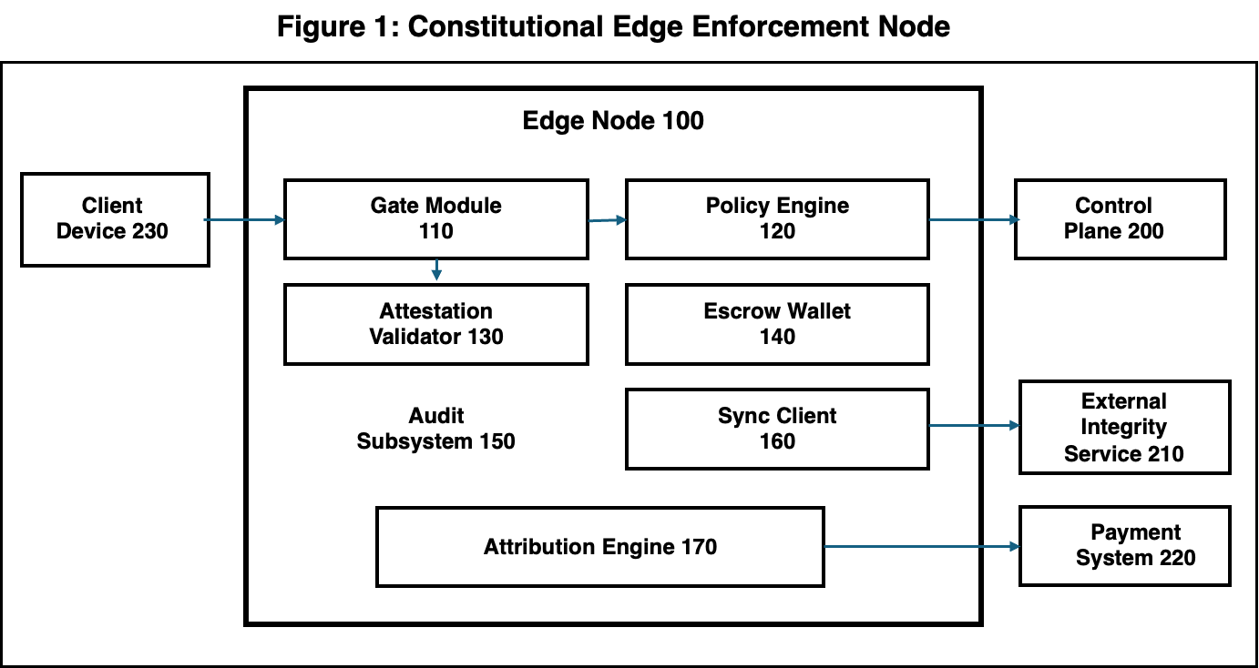
Figure 1 - illustrates an example constitutional edge enforcement node 100 disposed between a client device 230 and one or more external services, including a control plane 200, an external integrity service 210, and a payment system 220. The edge node 100 includes a gate module 110 configured to receive execution requests from the client device 230 and enforce a no-token-no-run invariant based on decisions from a policy engine 120. An attestation validator 130 verifies platform and workload attestation evidence associated with the request, while an escrow wallet 140 maintains execution-linked economic escrows for approved workloads. An audit subsystem 150 records immutable audit events for each decision and resulting receipt, and a sync client 160 propagates checkpoints and audit artifacts to the external integrity service 210 and/or the control plane 200. An attribution engine 170 binds approved executions to cryptographic attribution metadata and generates execution receipts that may be consumed by the payment system 220 to perform settlement operations and royalty or fee distribution.

Figure 2: Flowchart of no-token-no-run invariant enforcement showing sequential validation of capability token, attestation evidence, policy evaluation, and attribution binding.
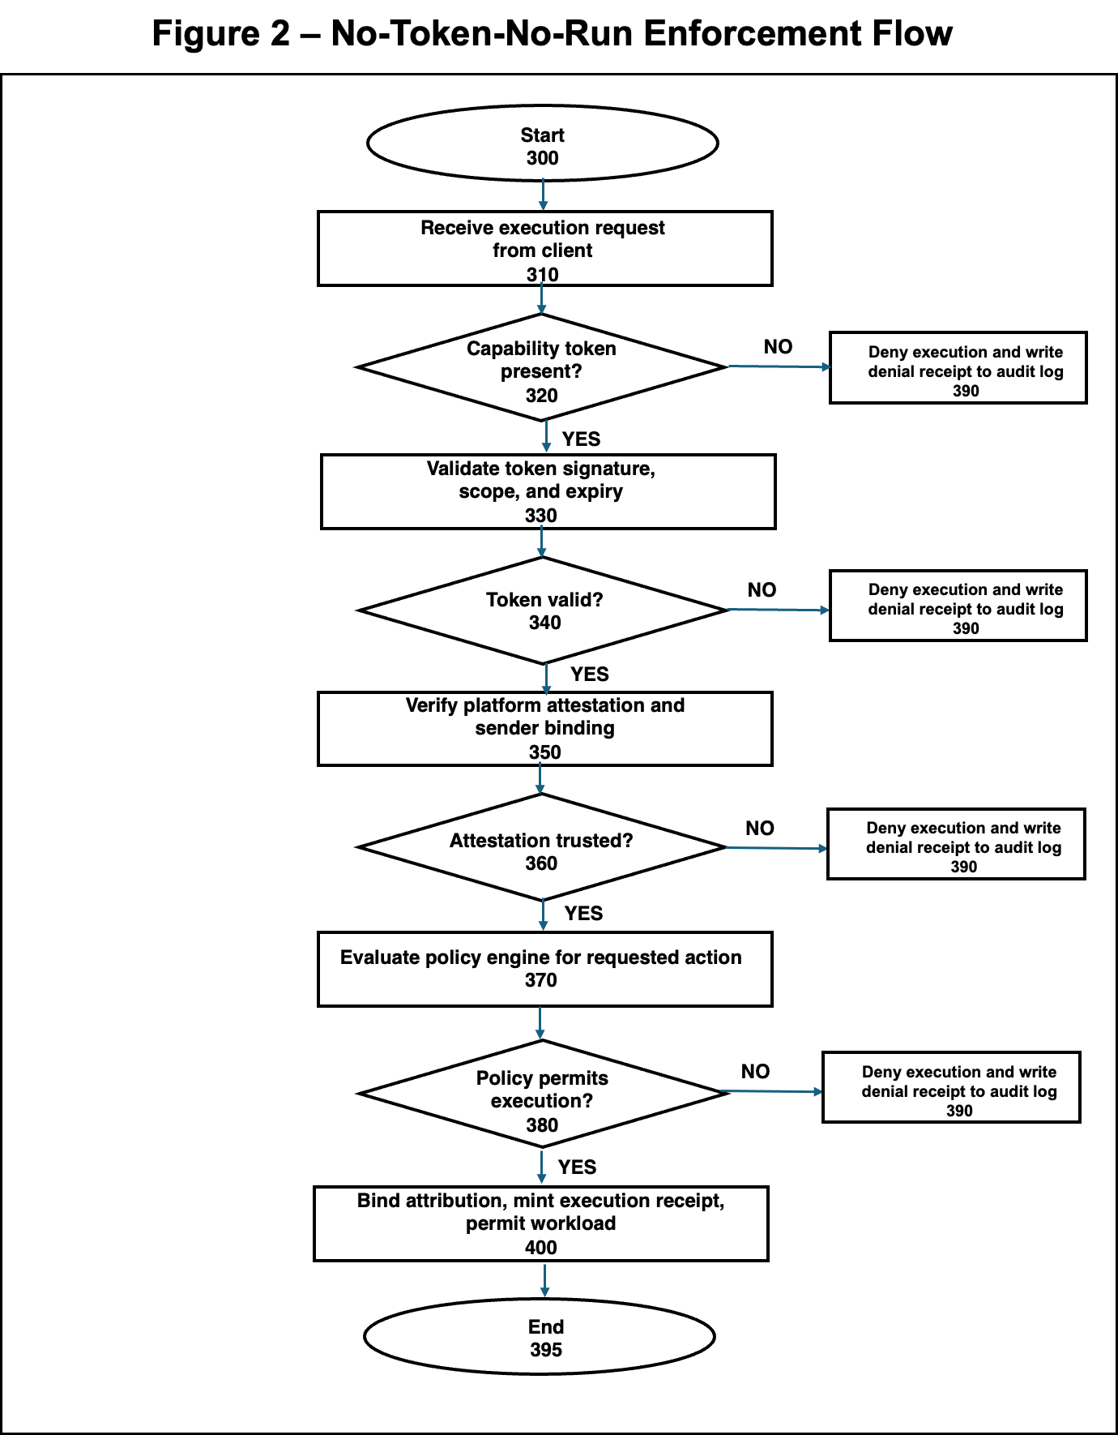
Figure 2 - is a flowchart illustrating enforcement of a no-token-no-run invariant at an edge node. The process begins at step 300, where the edge node receives an execution request from a client device (step 310). The gate module determines whether a capability token is present with the request (step 320). If no token is present, the system denies execution and writes a denial receipt to the audit log (step 390). If a token is present, the gate module validates the token’s digital signature, authorized scope, and expiration time (step 330), and determines whether the token is valid (step 340). If the token is invalid, the flow again transitions to the denial path (step 390).
When the token is valid, the edge node verifies platform attestation and sender binding (step 350) to ensure that the request originates from an attested hardware/software stack. The system checks whether the attestation is trusted (step 360), and if not, denies execution and records a denial receipt (step 390). For trusted attestation, the policy engine is evaluated for the requested action (step 370) to determine if current policies permit execution (step 380). If the policy evaluation fails, the request is denied and logged (step 390). If the policy evaluation succeeds, the attribution engine binds attribution information to the request, mints an execution receipt, and permits the workload to execute (step 400). The process then terminates.

Figure 3: Diagram of sender-constrained capability token structure showing cnf claim, key thumbprint, scope constraints, temporal validity, and sequence numbers.
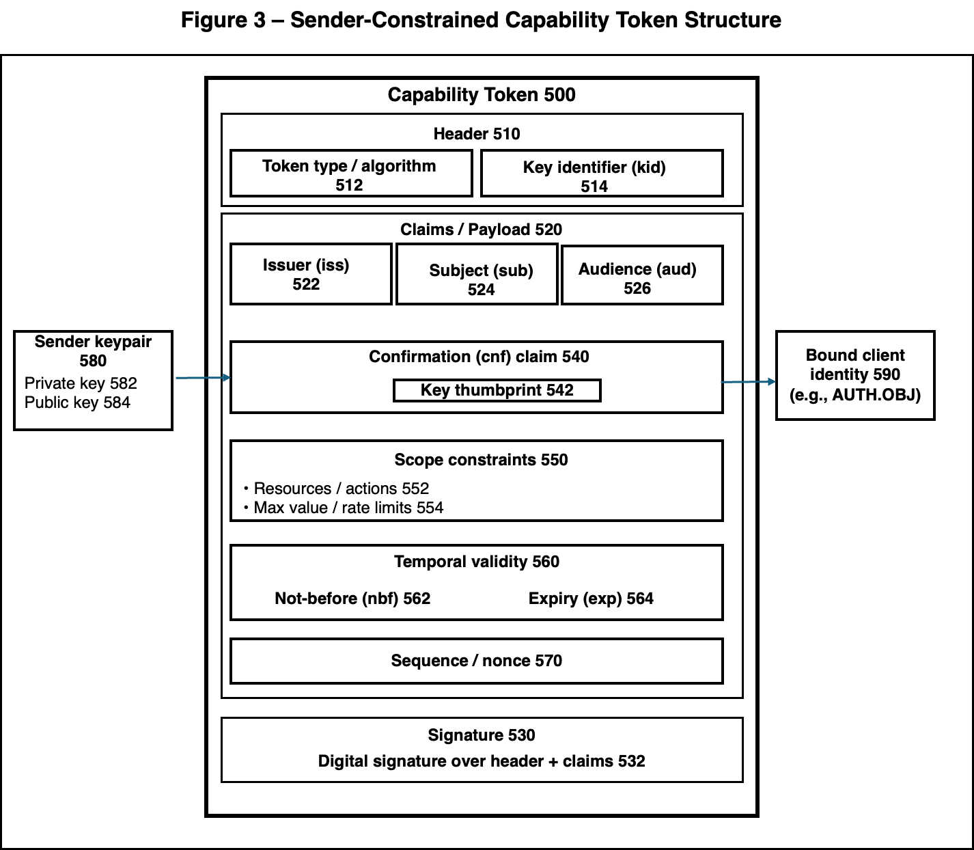
Figure 3 - illustrates an example sender-constrained capability token 500. The token includes a header 510 with a token type and/or algorithm field 512 and a key identifier (kid) field 514. A claims or payload section 520 contains standard identity claims such as issuer (iss) 522, subject (sub) 524, and audience (aud) 526. A confirmation (cnf) claim 540 carries a key thumbprint 542 that binds the token to a particular sender keypair 580, which includes a private key 582 and corresponding public key 584. Scope constraints 550 specify permitted resources or actions 552 and associated maximum value and/or rate limits 554. A temporal validity section 560 includes a not-before (nbf) time 562 and an expiry (exp) time 564. A sequence or nonce field 570 provides replay protection. The entire token is protected by a signature 530 computed over the header 510 and claims 520, and may be further bound to a specific client or agent identity 590 (for example, an AUTH.OBJ) as shown.

Figure 4: Architecture diagram of compiled policy engine showing policy compilation to intermediate representation, runtime execution with resource bounds, and host interface for attestation and state access.
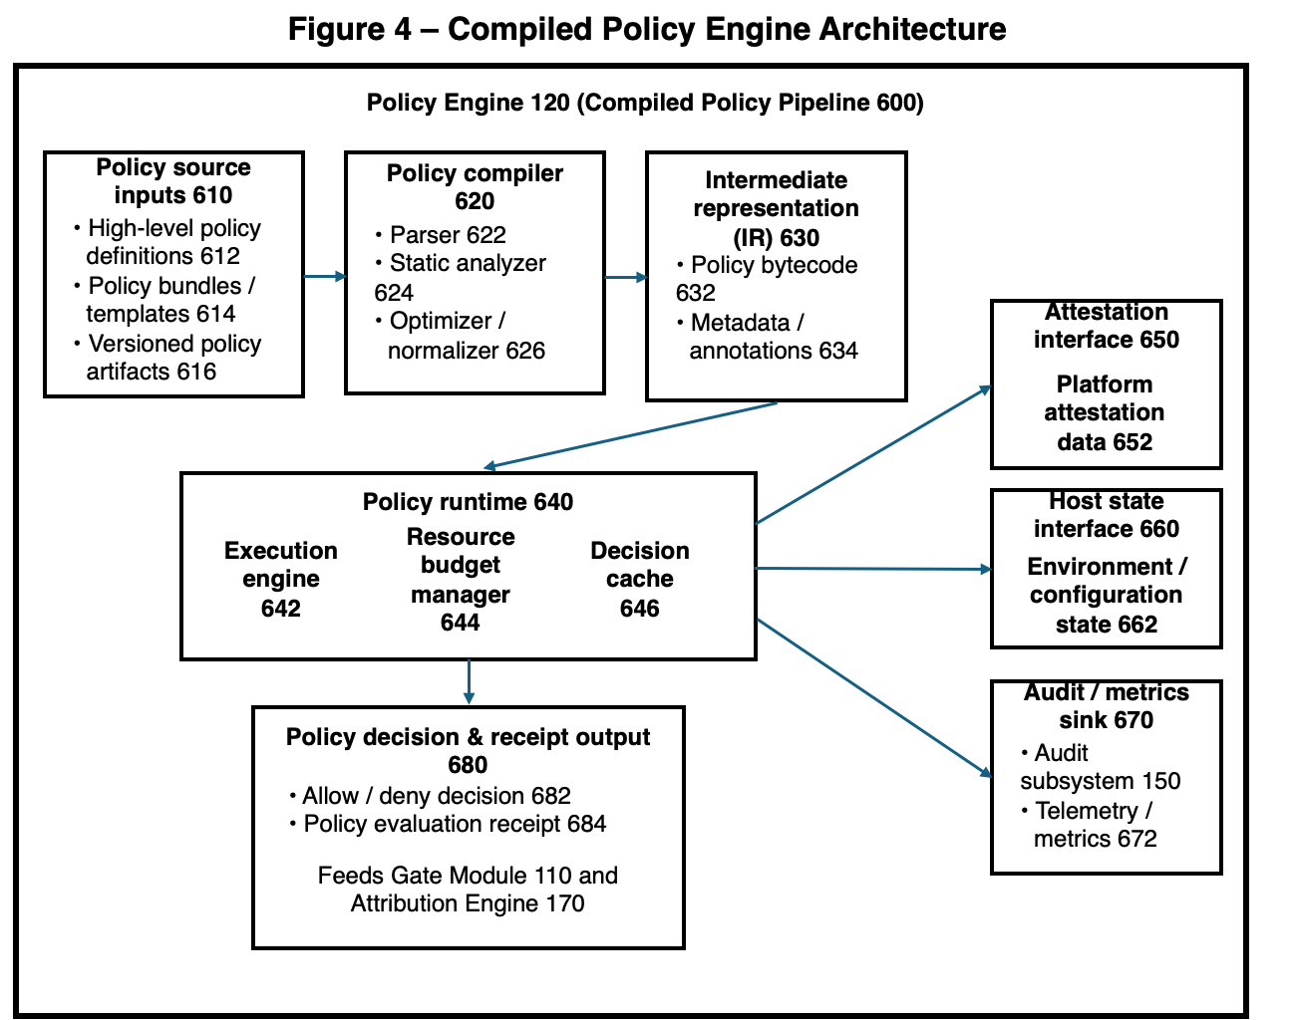
Figure 4 - illustrates an example compiled policy engine architecture. Policy engine 120 implements a compiled policy pipeline 600 that accepts policy source inputs 610, including high-level policy definitions 612, policy bundles or templates 614, and versioned policy artifacts 616. A policy compiler 620 processes these inputs using a parser 622, static analyzer 624, and optimizer/normalizer 626 to produce an intermediate representation (IR) 630, such as policy bytecode 632 with associated metadata and annotations 634. A policy runtime 640 executes the compiled IR using an execution engine 642, a resource budget manager 644 that enforces limits on CPU, memory, or other resources, and a decision cache 646 for previously evaluated decisions. During evaluation, the runtime obtains platform attestation data 652 via attestation interface 650 and environment or configuration state 662 via host state interface 660, and exports telemetry or metrics 672 to audit/metrics sink 670, which may be backed by audit subsystem 150. The runtime produces policy decision and receipt output 680, including an allow/deny decision 682 and a policy evaluation receipt 684, which are supplied to gate module 110 and attribution engine 170 to support no-token-no-run enforcement and verifiable attribution.
Figure 5: Sequence diagram of authenticated service discovery showing client resolver, DNS infrastructure, DNSSEC validation, TLSA pinning, and fallback mechanisms.
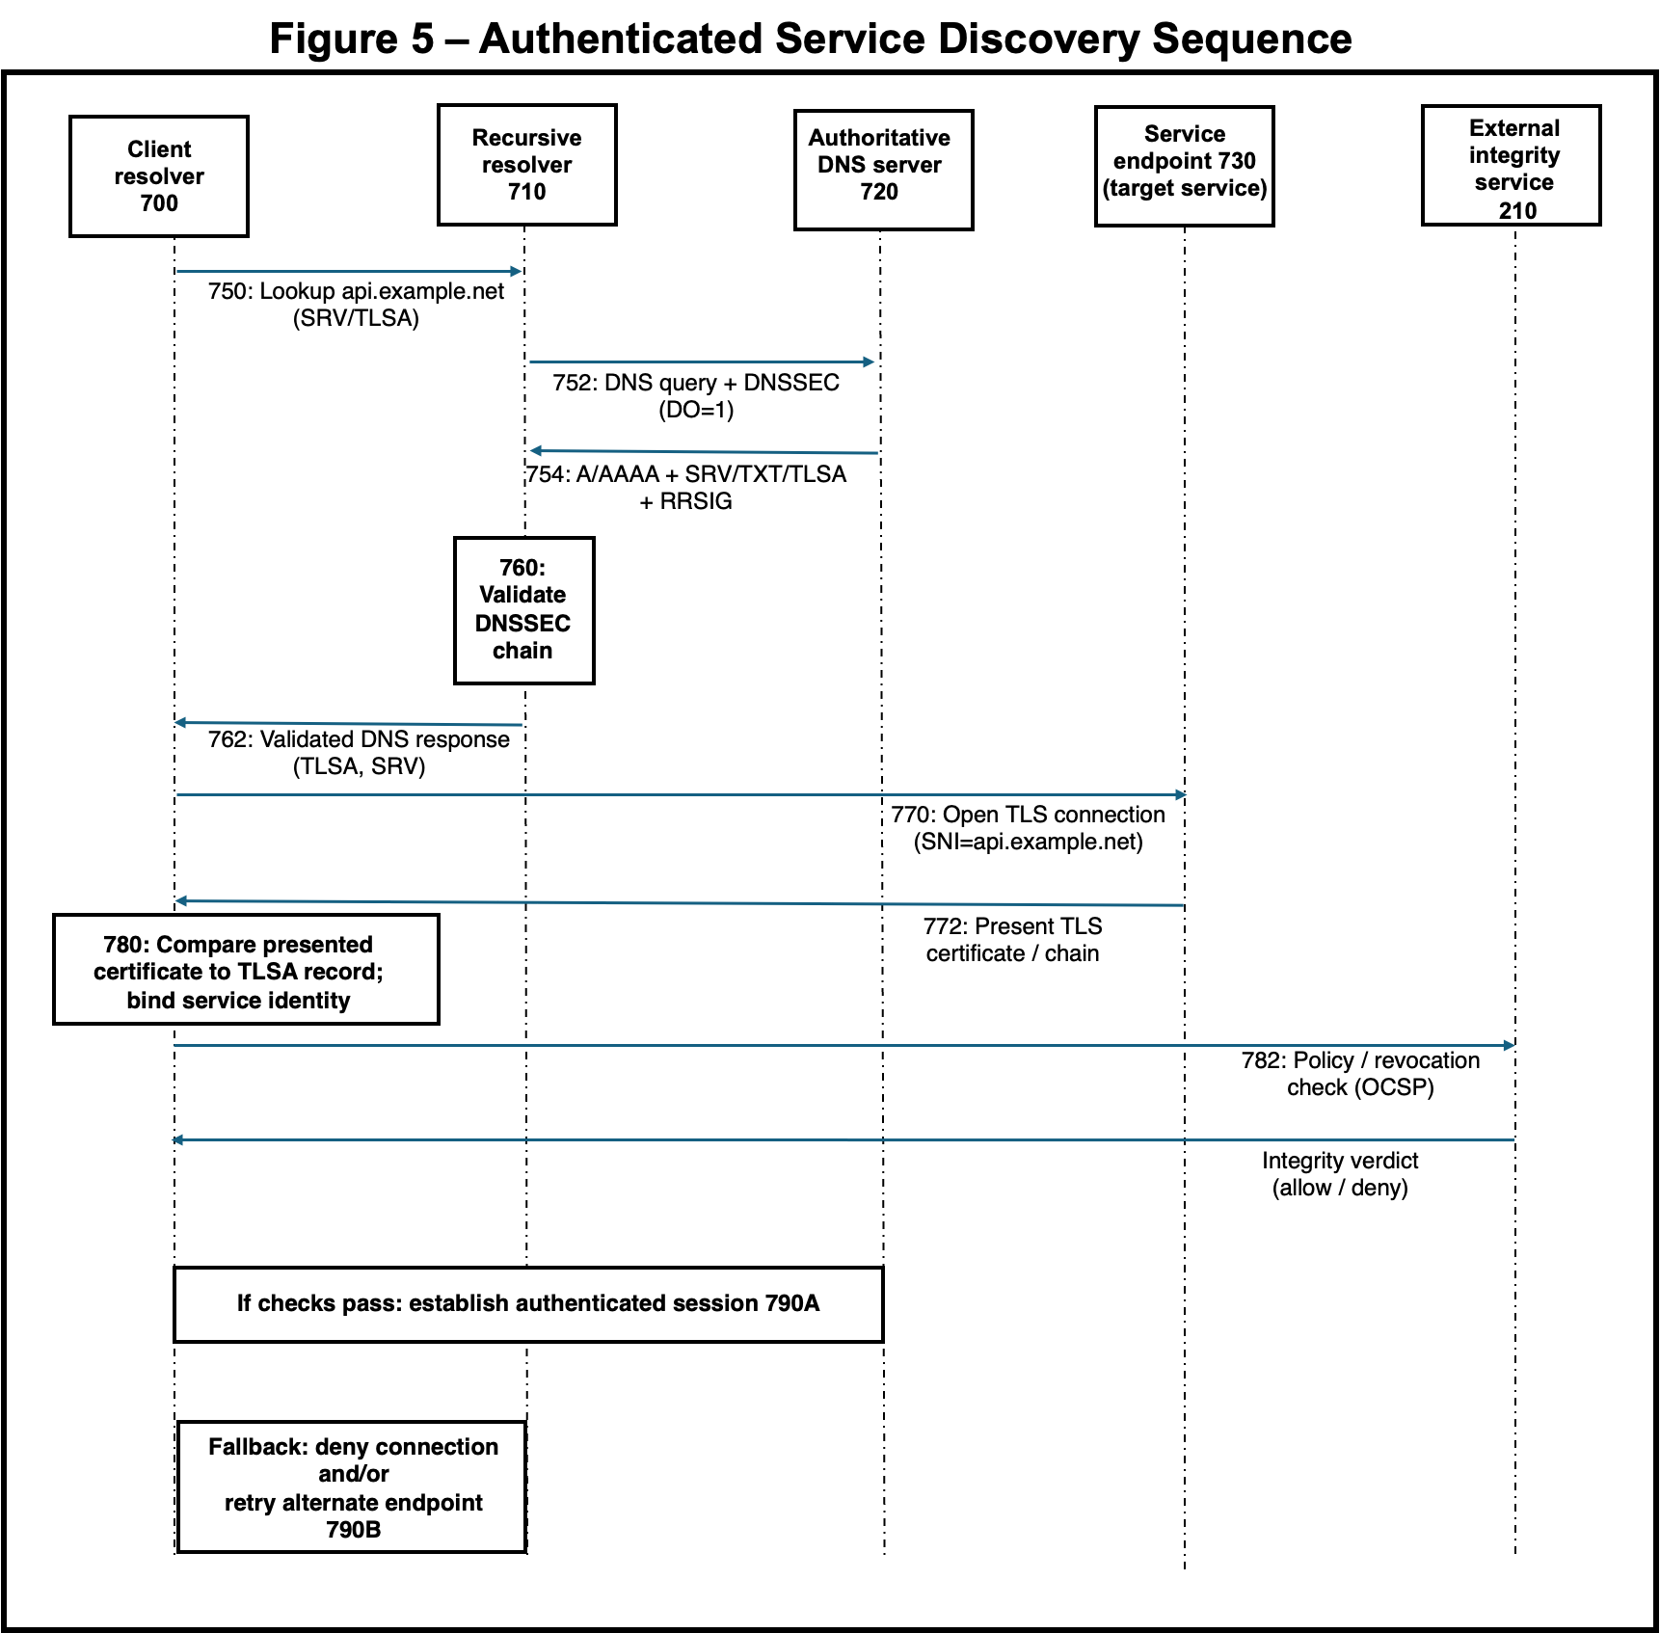
Figure 5 - is a sequence diagram illustrating an authenticated service discovery sequence between a client resolver 700, a recursive resolver 710, an authoritative DNS server 720, a target service endpoint 730, and an external integrity service 210. The client resolver 700 issues a DNS lookup for a service record (e.g., SRV/TLSA) which is forwarded by the recursive resolver 710 as a DNSSEC-enabled query 752 to the authoritative DNS server 720. The authoritative DNS server 720 returns signed responses 754 including address, service, and TLSA records, which the recursive resolver 710 validates using the DNSSEC chain 760 before providing a validated response 762 back to the client resolver 700. The client resolver 700 then opens a TLS connection 770 to the service endpoint 730, receives a presented certificate and chain 772, and compares the certificate to the previously obtained TLSA record 780 to bind the service identity. The external integrity service 210 performs a policy and revocation check 782 (e.g., OCSP), returning an integrity verdict that is used to either establish an authenticated session 790A if all checks pass or to deny the connection and optionally retry an alternate endpoint 790B if validation fails.

Figure 6: Block diagram of durable audit subsystem showing write-ahead log, hash-chaining, Merkle tree construction, checkpoint generation, and external anchoring.
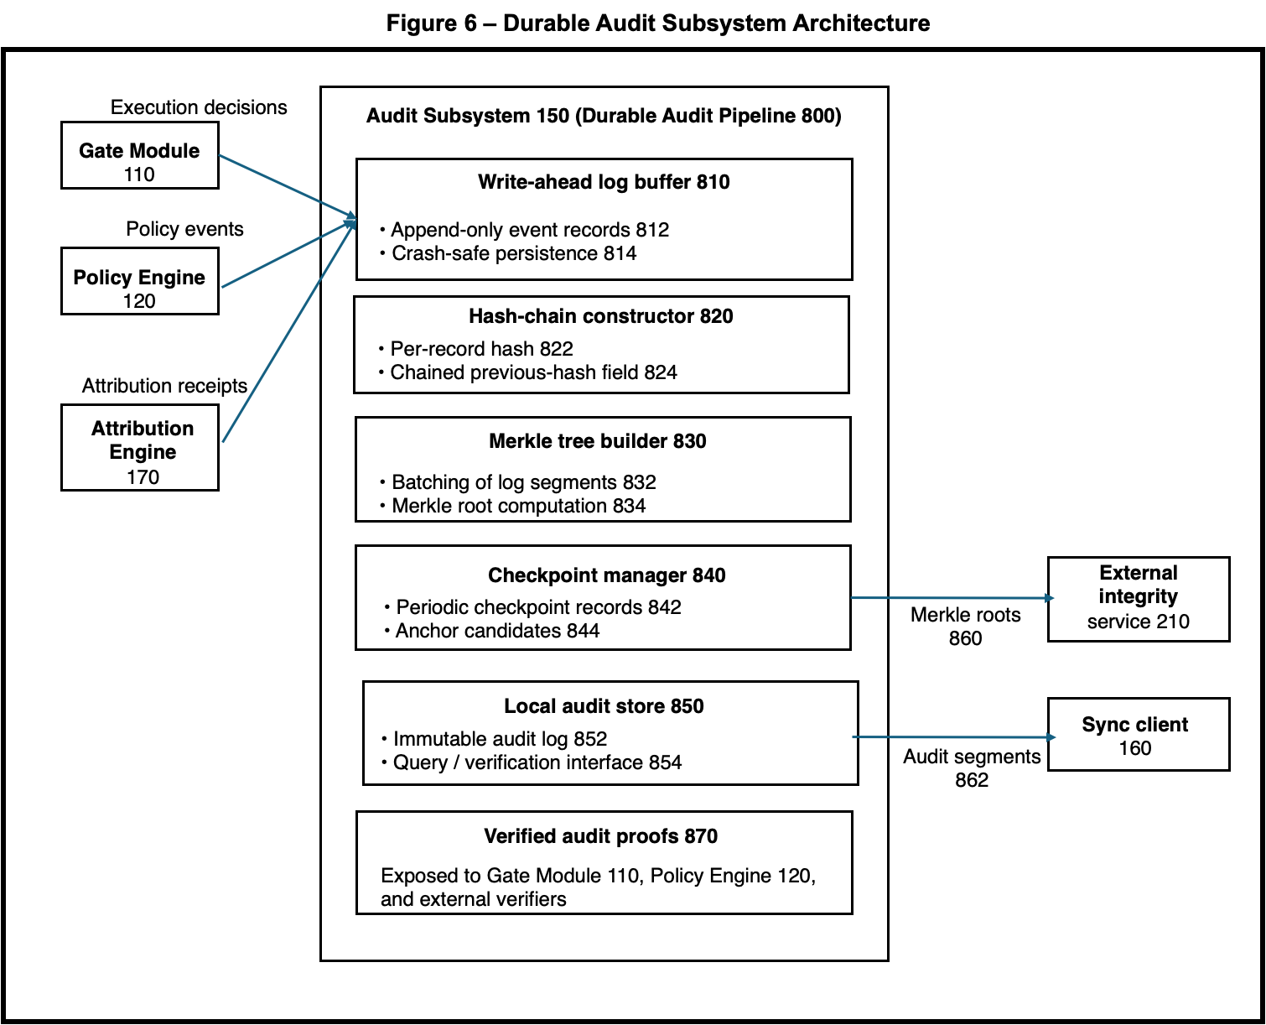
Figure 6 - is a block diagram of an example durable audit subsystem 150 implementing a durable audit pipeline 800. The audit subsystem 150 receives execution decisions from gate module 110, policy events from policy engine 120, and attribution receipts from attribution engine 170, and appends them as event records to a write-ahead log buffer 810 that provides append-only semantics and crash-safe persistence. A hash-chain constructor 820 computes a per-record hash for each appended entry and maintains a chained previous-hash field to provide tamper-evident sequencing of the log. A Merkle tree builder 830 batches log segments and computes Merkle roots over the batched records. A checkpoint manager 840 emits periodic checkpoint records and identifies candidate roots for external anchoring. A local audit store 850 maintains an immutable audit log and exposes a query and verification interface for later inspection. Verified audit proofs 870 derived from the Merkle tree structure are exposed back to gate module 110, policy engine 120, and external verifiers. Merkle roots 860 are exported to an external integrity service 210 for independent anchoring, and replicated audit segments 862 are provided to sync client 160 for remote backup and recovery.
Figure 7: Network diagram of peer mesh delegation showing capability announcements, trust scoring, workload delegation, receipt exchange, and attribution lineage preservation.
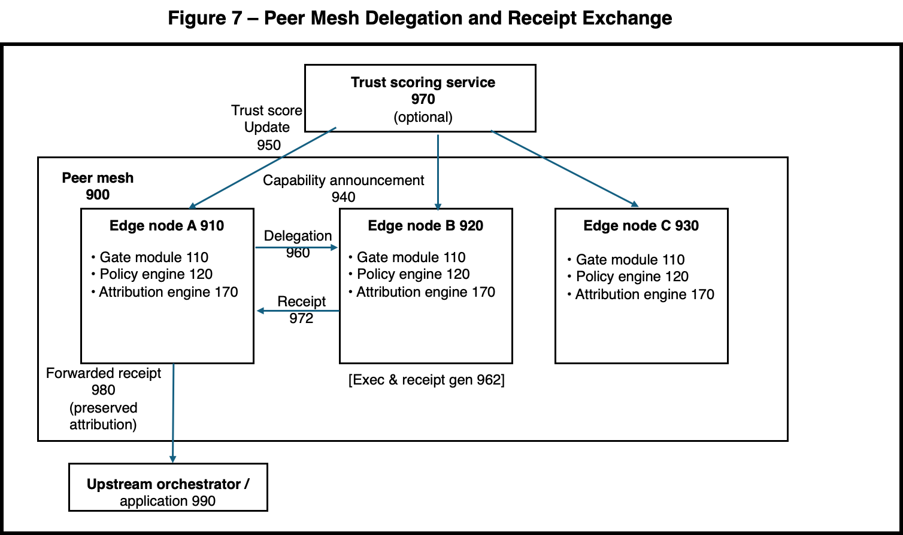
Figure 7 - is a network diagram of a peer mesh 900 in which multiple edge nodes (edge node A 910, edge node B 920, and edge node C 930) each include a gate module 110, policy engine 120, and attribution engine 170 and advertise their capabilities via capability announcements 940. A trust scoring service 970 optionally receives trust score updates 950 from the mesh and returns updated trust scores that influence delegation decisions 960 from one edge node to another. When a delegated workload is executed, the selected edge node generates a receipt 972 and forwards a preserved-attribution receipt 980 to an upstream orchestrator or application 990, thereby maintaining attribution lineage across delegated execution within the peer mesh.
Figure 8: Timeline diagram of offline reconciliation showing receipt accumulation, hash chain construction, checkpoint generation, reconnection, conflict resolution, and external anchoring.
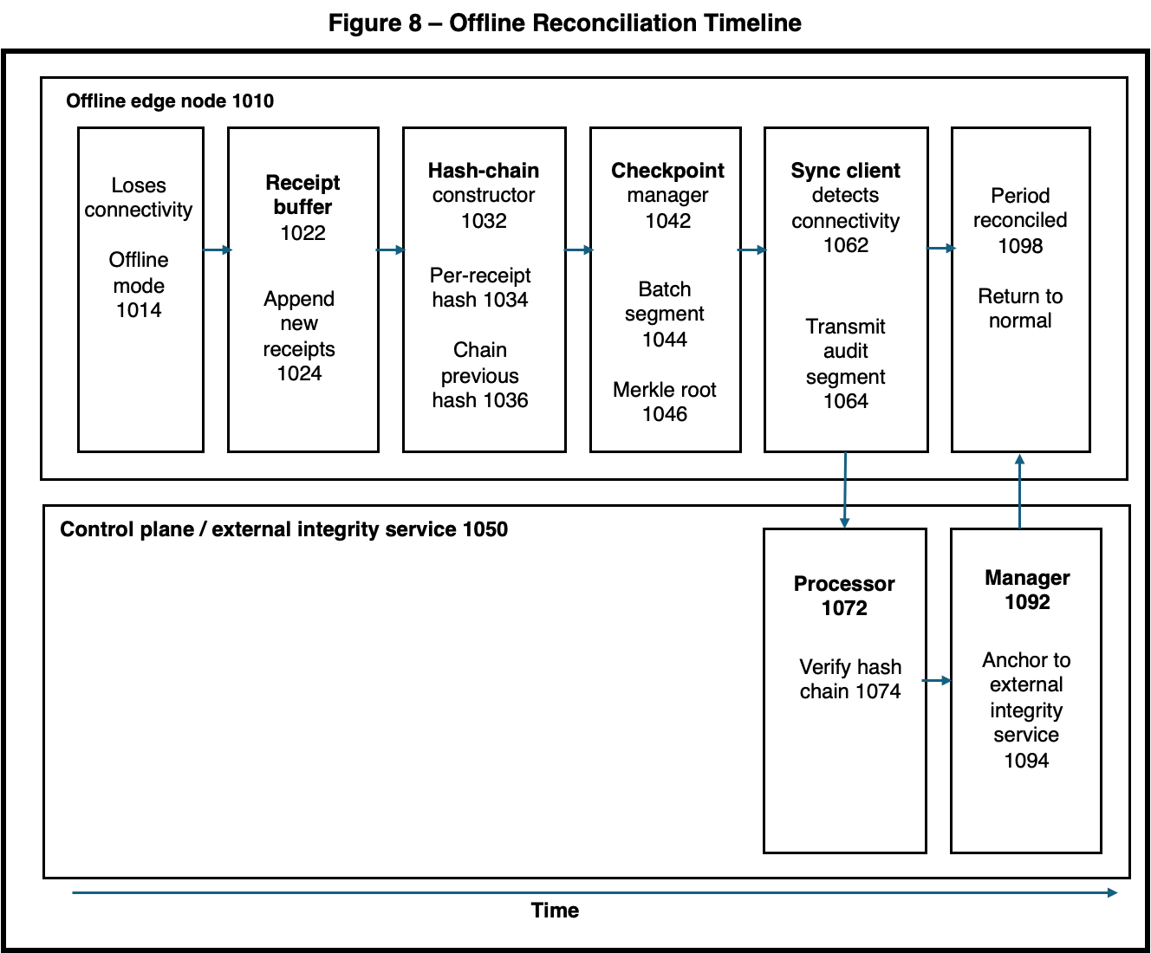
Figure 8 - illustrates an offline reconciliation timeline between an edge node and a control-plane or external integrity service. When the offline edge node 1010 loses connectivity and enters offline mode 1014, new receipts are appended to a local receipt buffer 1022 and incorporated into a hash chain by a hash-chain constructor 1032 using per-receipt hashes 1034 and chained previous-hash fields 1036. A checkpoint manager 1042 periodically batches receipts into a segment 1044 and computes a Merkle root 1046, which is later transmitted by a sync client 1062 as an audit segment 1064 once connectivity is restored. On the control-plane side 1050, a processor 1072 verifies the received hash chain 1074, and a manager 1092 anchors the verified state to an external integrity service 1094 so that the period is fully reconciled 1098 and the system returns to normal operation.
Figure 9: Data flow diagram of attribution-governed economic routing showing provenance chains, royalty computation, distribution weight calculation, and direct peer-to-peer payment routing.
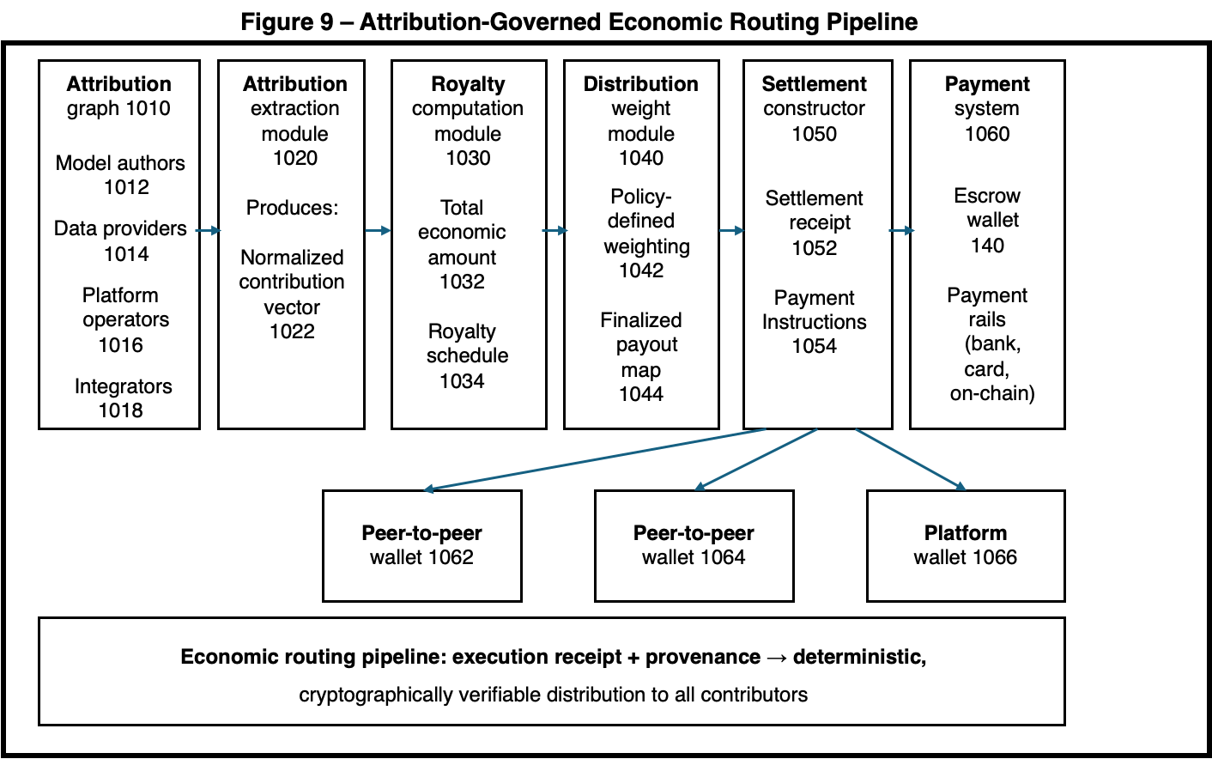
Figure 9 - is a block diagram of an attribution-governed economic routing pipeline showing how execution receipts and provenance drive deterministic payout. An attribution graph 1010 (including model authors 1012, data providers 1014, platform operators 1016, and integrators 1018) is processed by an attribution extraction module 1020 to produce a normalized contribution vector 1022, which is supplied to a royalty computation module 1030 that determines a total economic amount 1032 and royalty schedule 1034. A distribution weight module 1040 applies policy-defined weighting 1042 to generate a finalized payout map 1044, which is consumed by a settlement constructor 1050 that builds a settlement receipt 1052 and payment instructions 1054 for a payment system 1060 using an escrow wallet 140 and payment rails such as bank, card, or on-chain transfers. The payment instructions fund one or more peer-to-peer wallets 1062, 1064 and a platform wallet 1066, yielding an economic routing pipeline in which execution receipts plus provenance result in deterministic, cryptographically verifiable distribution of value to all contributors.

CONCLUSION
This provisional patent application describes systems and methods for constitutional policy enforcement at edge execution boundaries with hardware-anchored attribution. The invention enables distributed edge nodes to enforce governance requirements, preserve attribution integrity, and maintain economic participation during offline operation through cryptographic mechanisms including sender-constrained capability tokens, compiled policy evaluation, authenticated service discovery, durable audit commits, trust-weighted mesh delegation, offline-capable reconciliation, and attribution-governed economic routing. The fail-closed no-token-no-run invariant ensures constitutional requirements are technically enforced rather than procedurally recommended, providing security guarantees suitable for edge deployments in hostile environments with intermittent connectivity.

